**Attendance For Impact**

1. **Part 1**

**Analysis of Entrance Exam Performance and Its Impact on College Subject Performance**

**Objective**

The purpose of this analysis is to determine whether students who excelled in entrance-based subjects (Mathematics, Physics, Chemistry) continue to perform better in college courses that are conceptually related to their entrance subjects (Math-1, Physics, Math-2, and Fundamentals of Electronics and Electrical Theory). Furthermore, we compare their performance in these subjects to their performance in technical subjects (Java-1, Data Structures, DBMS, and Java-2) to assess whether the performance gap has diminished.

**Methodology**

1. **Data Extraction:**
   * The dataset used for this analysis is college.csv, which contains student performance data.
   * The department of each student is identified using the Div-1 column, where the first character represents the department (A, B, or D).
   * The internal roll number within each department is extracted from the Roll-1 column.
2. **Performance Calculation:**
   * **Entrance Rank Percentile** is calculated using the Roll-1 column by ranking students within their department.
   * **12th-Based Performance** is computed as the average of:
     + Math-1 Theory
     + Physics Theory
     + Math-2 Theory
     + Fundamentals of Electronics and Electrical Theory
   * **Technical Performance** is computed as the average of:
     + Java-1 Theory
     + Data Structures using Java Theory
     + DBMS Theory
     + Java-2 Theory
   * Percentiles are determined for both **12th-Based Performance** and **Technical Performance** by ranking the respective averages within the department.
3. **Analysis and Visualization:**
   * Scatter plots with regression lines are generated for each department (A, B, and D):
     + **Entrance Rank Percentile vs. 12th-Based Subject Performance Percentile**
     + **Entrance Rank Percentile vs. Technical Subject Performance Percentile**
   * The regression equations and correlation coefficients are recorded for interpretation.

**Results and Interpretation**

* The regression equations and correlation coefficients (r-values) provide insight into the relationship between entrance exam performance and college subject performance.

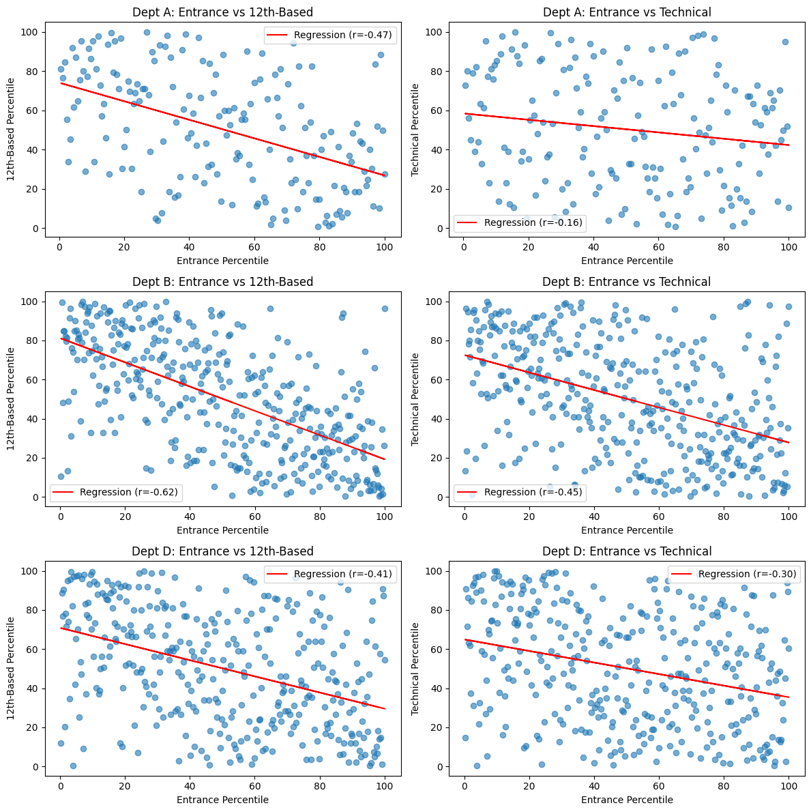

* The department-wise regression results are as follows:  
  + **Dept A (12th-Based):** y = -0.47x + 74.06, r = -0.47
  + **Dept A (Technical):** y = -0.16x + 58.38, r = -0.16
  + **Dept B (12th-Based):** y = -0.62x + 81.19, r = -0.62
  + **Dept B (Technical):** y = -0.45x + 72.57, r = -0.45
  + **Dept D (12th-Based):** y = -0.41x + 70.86, r = -0.41
  + **Dept D (Technical):** y = -0.30x + 64.95, r = -0.30
* Department B, which corresponds to the **CSE course**, had a higher cutoff than other courses. This could explain why its **12th-Based regression (r = -0.62)** is the highest among all departments, as only the top-scoring students were accepted into the course.
* The negative slope values across all regressions indicate an inverse relationship between entrance percentile (lower values indicate better ranks) and performance percentiles, implying that students who secured better ranks in entrance exams tend to perform well in both subject categories.
* However, the correlation is notably stronger for **12th-Based subjects** across all departments, indicating that students who were strong in entrance exam subjects continue to excel in related college subjects.
* The correlation with **technical subjects** is slightly weaker in all cases, suggesting that while entrance exam performance is still a factor, additional skills and learning curves may play a role in technical subject mastery.

**Implications**

* The findings suggest that entrance exam ranks are a reliable indicator of academic success in 12th-based subjects but are slightly less predictive for technical subjects.
* The relatively lower correlation in technical subjects could imply that these subjects require different skill sets that are not entirely captured by entrance exam performance.
* For educators and policymakers, this may indicate the need for bridging courses or preparatory modules to help students transition effectively into technical subjects.
* Future research could explore additional factors such as study habits, practical assessments, and cognitive skill differences that might contribute to success in technical subjects.

1. Part 2

**Section for Research Paper: Analysis of Mentor Impact Using ANOVA**

**1. Introduction**

The mentor system in educational institutions is often implemented to provide guidance and support to students. However, the actual impact of assigned mentors on student performance remains an open question. This study investigates whether mentor assignments influence student outcomes in terms of **attendance, theory marks, and practical marks**. Given that mentors are assigned randomly, any significant differences in student performance should indicate a meaningful impact of mentorship, while a lack of significant variation would suggest otherwise.

To test this, we use **One-Way ANOVA (Analysis of Variance)**, which compares the means of student performance metrics across different mentors. If the **p-value** from ANOVA is less than **0.05**, it indicates a statistically significant difference, suggesting that the mentor assignment does influence student performance.

**2. Methodology**

The dataset consists of student performance metrics from two semesters, where each student has a randomly assigned mentor. The following steps were performed:

1. **Compute Average Metrics:**
   * **Average Attendance**: Mean attendance across all subjects in the semester.
   * **Average Theory Marks**: Mean of all theory subject scores.
   * **Average Practical Marks**: Mean of all practical subject scores.
2. **Perform One-Way ANOVA** to test whether mentor assignment has a significant impact on these metrics.
3. **Interpret Results** based on p-values and visualize distributions using boxplots.

**3. Results and Discussion**

**Semester 1 Results**

|  |  |  |
| --- | --- | --- |
| **Metric** | **p-value** | **Interpretation** |
| Attendance | 0.696 | No significant effect |
| Theory Marks | 0.056 | Weak, but not significant effect |
| Practical Marks | 0.728 | No significant effect |

For Semester 1, the p-values for attendance and practical marks are **well above 0.05**, suggesting that mentor assignment does not impact these metrics. Theory marks exhibit a p-value of **0.056**, which is close to significance but still does not meet the threshold, indicating only a weak potential effect.

**Semester 2 Results**

|  |  |  |
| --- | --- | --- |
| **Metric** | **p-value** | **Interpretation** |
| Attendance | 0.217 | No significant effect |
| Theory Marks | 0.129 | No significant effect |
| Practical Marks | **0.015** | **Significant effect** |

For Semester 2, both **attendance and theory marks show no significant mentor effect**. However, practical marks have a **p-value of 0.015**, which is **below 0.05**, indicating that mentor assignment has a **statistically significant impact** on practical performance. This suggests that some mentors may be more actively involved in practical sessions or that different mentors grade practical work with varying levels of leniency.

**Semester 1 Box-Plots**

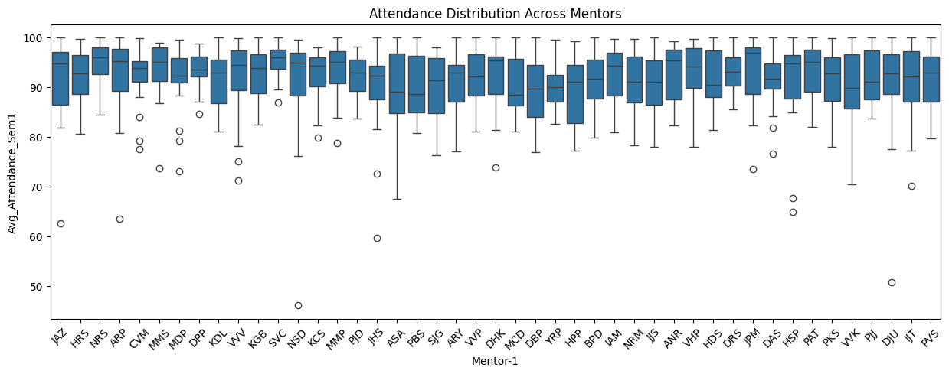

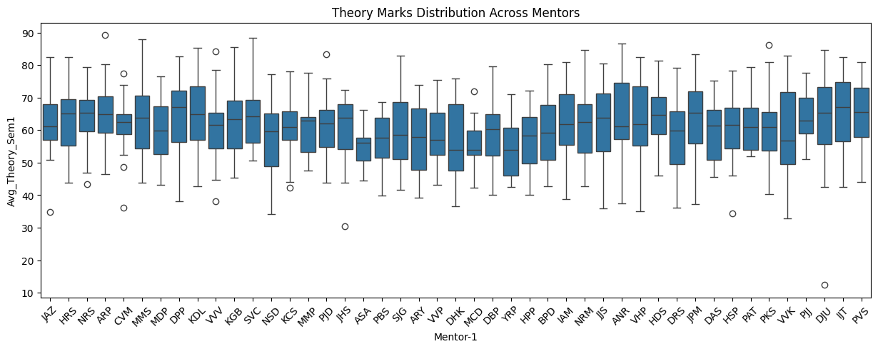

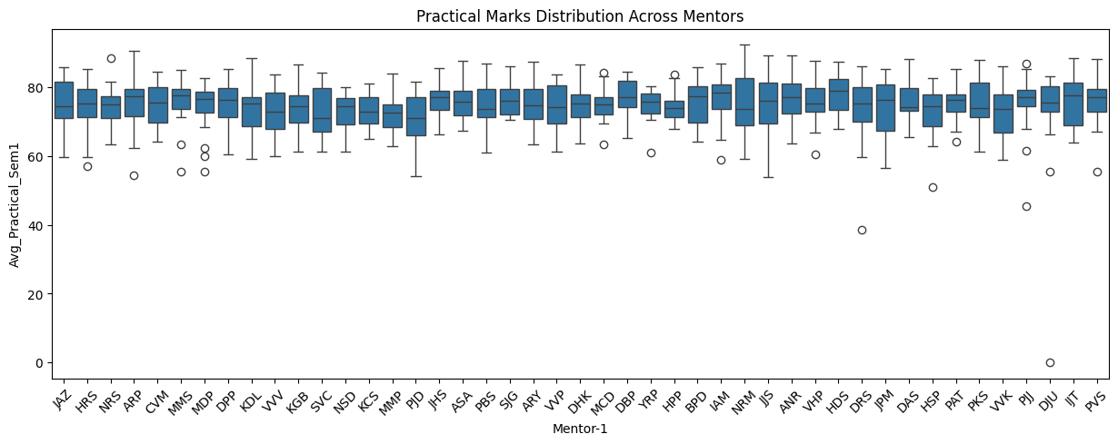

**Semester 2 Box-Plots**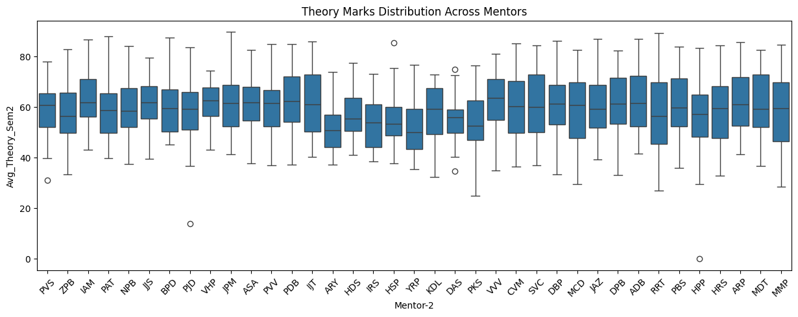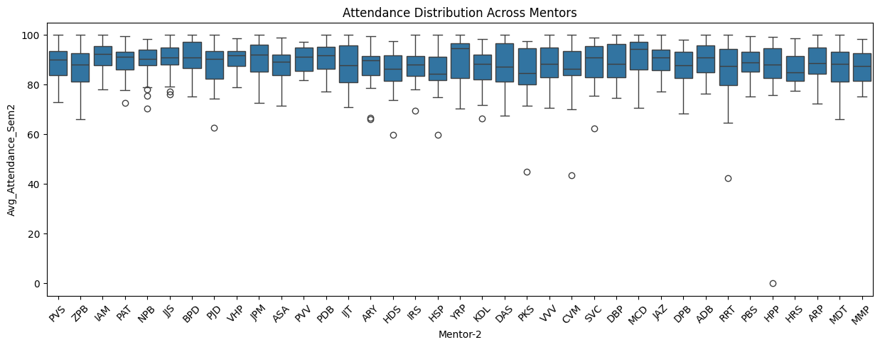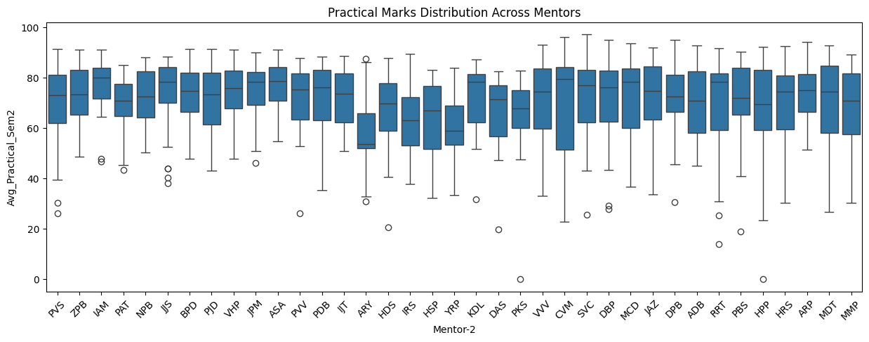

**4. Conclusion**

The results suggest that **mentor assignment has no statistically significant impact on attendance or theory marks**. However, **practical marks in Semester 2 show a significant mentor effect**, potentially indicating variations in mentor engagement or grading patterns for practical work. Further investigation using **post-hoc tests** (such as Tukey’s HSD) could help identify which mentors exhibit significantly different practical score distributions.

**Analysis of Mentor Influence on Student Performance**

The results of the ANOVA analysis indicate that **mentor assignment had no statistically significant impact on attendance, theory marks, or practical marks in Semester 1**. The p-values for attendance (**p = 0.696**), theory marks (**p = 0.056**), and practical marks (**p = 0.728**) suggest that there is no meaningful difference in student performance based on mentor assignment.

In **Semester 2**, the ANOVA results similarly show **no significant effect of mentor assignment on attendance (p = 0.217) and theory marks (p = 0.129)**. However, practical marks exhibit a statistically significant difference (**p = 0.015**). Given that no such effect was observed in **Semester 1** and that the difference is only present in one metric (practical marks), this result is likely due to **random variation rather than a true mentor influence**.

1. Part 3

**Correlation Analysis of Practical Marks in a Combined Project**

**Introduction**

This study investigates the correlation between practical marks in a combined project that integrated three subjects: Data Structures (DS), Database Management Systems (DBMS), and Java-2. Despite these subjects evaluating different skills—DBMS focusing on SQL proficiency, DS assessing algorithm implementation, and Java-2 measuring software development—the practical marks exhibit a strong correlation, indicating possible grading bias by examiners.

To validate this claim, we conducted a correlation analysis:

1. **Assess the correlation among DS, DBMS, and Java-2 practicals.**
2. **Compare the correlation between Java-1 (Semester 1) and Java-2 (Semester 2) to determine if the combined project influences the grading.**
3. **Examine whether other subjects in Semester 1 and Semester 2 exhibit a similarly strong correlation to confirm the uniqueness of this pattern.**

**Methodology**

We used the dataset **"college.csv"**, which contains practical marks for all subjects. We computed the Pearson correlation matrix using Matplotlib and Pandas to visualize the relationships.

**Code Implementation**

import pandas as pd

import matplotlib.pyplot as plt

import seaborn as sns

# Load dataset

file_path = "college.csv"

df = pd.read_csv(file_path)

# Selecting only relevant columns

target_columns = [

"Physics Practical", "Java-1 Practical", "Software Engineering Practical",

"IOT Workshop Practical", "Computer Workshop Practical", "Data Structures using Java Practical",

"DBMS Practical", "Fundamental of Electronics and Electrical Practical", "Java-2 Practical",

"Java-2 Theory", "DBMS Theory", "Data Structures using Java Theory"

]

df = df[target_columns] # Ensure only relevant columns are used

# Define subjects other than trio

sem_1_and_2_subjects = [

"Physics Practical", "Java-1 Practical", "Software Engineering Practical",

"IOT Workshop Practical", "Computer Workshop Practical", "Fundamental of Electronics and Electrical Practical"

]

subject_trio_practical = [

"Java-2 Practical", "DBMS Practical", "Data Structures using Java Practical"

]

# Compute correlation matrix

correlation_matrix = df.corr()

# Extract relevant correlations

ds_dbms_java2_corr = correlation_matrix.loc[subject_trio_practical, subject_trio_practical]

java1_java2_corr = correlation_matrix.loc["Java-1 Practical", "Java-2 Practical"]

other_sem1_sem2_corr = correlation_matrix.loc[sem_1_and_2_subjects, subject_trio_practical]

# Plot correlation matrix for DS, DBMS, Java-2

plt.figure(figsize=(8, 6))

sns.heatmap(ds_dbms_java2_corr, annot=True, cmap="coolwarm", fmt=".2f")

plt.title("Correlation Matrix of DS, DBMS, and Java-2 Practicals")

plt.show()

# Display correlation values

print("Correlation between Java-1 and Java-2 Practical:", java1_java2_corr)

print("Other Semester 1 and Semester 2 Subject Correlations:")

print(other_sem1_sem2_corr)

# Selecting only theory of trio subjects

subject_trio_theory = [

"Java-2 Theory", "DBMS Theory", "Data Structures using Java Theory"

]

# Compute correlation matrix

ds_dbms_java2_theory_corr = correlation_matrix.loc[subject_trio_theory, subject_trio_theory]

# Plot correlation matrix for theory subjects

plt.figure(figsize=(8, 6))

sns.heatmap(ds_dbms_java2_theory_corr, annot=True, cmap="coolwarm", fmt=".2f")

plt.title("Correlation Matrix of Java-2, DBMS, and Data Structures Theory")

plt.show()

**Results and Discussion**

The correlation analysis highlights the following key findings:

1. **Strong correlation within the DS-DBMS-Java-2 trio**
   * **Java-2 & DBMS Practical:** **0.90**
   * **Java-2 & Data Structures using Java Practical:** **0.94**
   * **DBMS & Data Structures using Java Practical:** **0.90**
   * This suggests that despite each subject evaluating different skills, examiners assigned highly similar marks, likely due to the **combined project.**

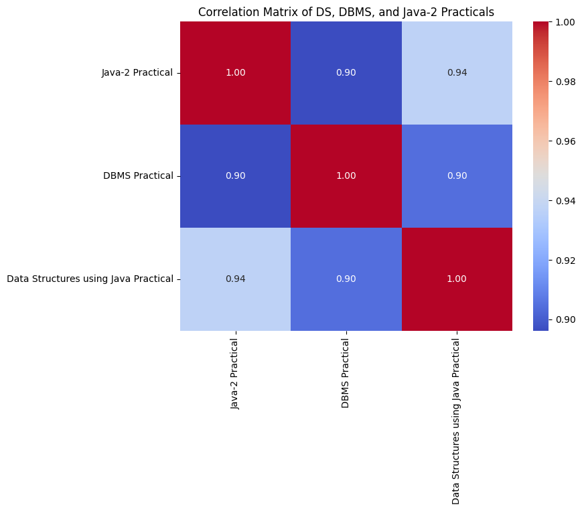

1. **Lower correlation between Java-1 and Java-2**
   * **Java-1 & Java-2 Practical:** **0.39**
   * Since both involve Java programming but were evaluated in different semesters without a combined project, this confirms that the **grading similarity in three subjects was due to the combined project, not subject continuity**.

Correlation between Java-1 and Java-2 Practical: 0.39010499148400124

1. **Weaker correlation of other subjects with the subject trio**
   * Most other subjects, including **Physics, Software Engineering, IOT Workshop, and Computer Workshop**, had correlations ranging from **0.22 to 0.51** with DS, DBMS, and Java-2.
   * This indicates that the **high correlation within the subject trio is an anomaly**, reinforcing the likelihood of **examiners grading the project as a whole rather than differentiating subject-specific aspects**.

Other Semester 1 and Semester 2 Subject Correlations:

**For Java-2 Practical:**

Physics Practical 0.325608

Java-1 Practical 0.390105

Software Engineering Practical 0.223259

IOT Workshop Practical 0.218557

Computer Workshop Practical 0.298241

Fundamental of Electronics and Electrical Pract... 0.511154

**For DBMS Practical:**

Physics Practical 0.361335

Java-1 Practical 0.439030

Software Engineering Practical 0.242534

IOT Workshop Practical 0.272755

Computer Workshop Practical 0.320867

Fundamental of Electronics and Electrical Pract... 0.596819

**For Data Structures using Java Practical:**

Physics Practical 0.324466

Java-1 Practical 0.402300

Software Engineering Practical 0.230358

IOT Workshop Practical 0.225648

Computer Workshop Practical 0.308910

Fundamental of Electronics and Electrical Pract... 0.543530

4. **Correlation in Theory Subjects**

* **Java-2 & DBMS Theory:** 0.78
* **Java-2 & Data Structures using Java Theory:** 0.72
* **DBMS & Data Structures using Java Theory:** 0.78  
  While the correlation in theory subjects is not as strong as in practicals, the moderately high values indicate that students' performances in these subjects followed a similar pattern. This could be due to interrelated concepts or grading leniency rather than a combined project effect.

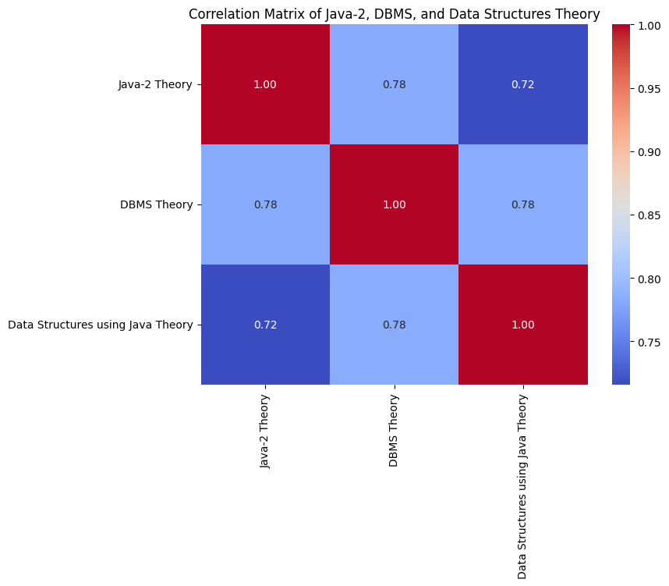

These findings strongly suggest a grading bias in **combined projects**, where examiners **did not differentiate practical marks according to distinct subject competencies**.

**Conclusion**

The findings indicate that **grading in subject trio may have been influenced by the combined project**, leading to **unintended uniformity in marks** across DS, DBMS, and Java-2 practicals. While each subject was designed to assess distinct skills, the strong correlations suggest that examiners might have **assessed the project holistically rather than subject-specifically**.

By contrast, the lower correlation between **Java-1 and Java-2 practicals** and the weaker correlation of **other Semester 1 and 2 subjects with the subject trio** indicate that such grading patterns are **not common across all subjects**. This strengthens the argument that the combined project was a key factor in the grading similarity.

**Implications**

* To ensure **fair evaluation**, future assessment frameworks should enforce **clear differentiation of marks** for subjects contributing to a combined project.
* Examiners should be **instructed to evaluate each subject independently**, avoiding the risk of grading bias.
* Institutions could introduce **separate assessment components** within projects, ensuring that subject-specific competencies are **distinctly measured**.

1. Part 4

#### **1. Introduction**

Academic success in engineering disciplines is often influenced by multiple factors, including attendance, theoretical understanding, and practical application. Understanding the relationship between these aspects can help educators and students make data-driven decisions to optimize learning outcomes. This study aims to analyze the correlation between **attendance, theoretical performance, and practical performance** across two semesters in an undergraduate AI & ML program.

#### **2. Purpose & Objectives**

The primary objective of this study is to explore the **correlation between attendance and academic performance** in different subjects across two semesters. Specifically, we aim to:

* Investigate **attendance correlations** across different subjects.
* Assess **how attendance in one semester influences attendance in subsequent semesters**.
* Examine **correlations in theory subject performance** across semesters.
* Analyze **practical subject performance and its interdependencies**.
* Provide insights on how students' engagement in one domain (attendance, theory, or practicals) impacts their overall academic trajectory.

#### **3. Methodology**

The study utilizes **correlation matrices** to identify relationships between attendance, theoretical scores, and practical performance. Additionally, **linear regression models** are used to explore **predictive relationships between predecessor and successor subjects** across semesters. The study is based on real-world attendance and academic performance data collected from students in an undergraduate program.

### **4.1 Attendance Analysis**

#### **4.1.1 Semester 1 Attendance Trends**

* Attendance patterns indicate strong correlations between subjects.
* **Mathematics-1 and Java-1 attendance (0.84)** show that students who attend math classes consistently also maintain attendance in programming courses.
* **Physics and Software Engineering attendance (0.81)** reinforce the trend of structured learning habits.
* A moderate correlation of **0.66** is observed between **Mathematics-1 & Mathematics-2** and **Java-1 & Java-2**, indicating a continuation of attendance patterns across semesters.

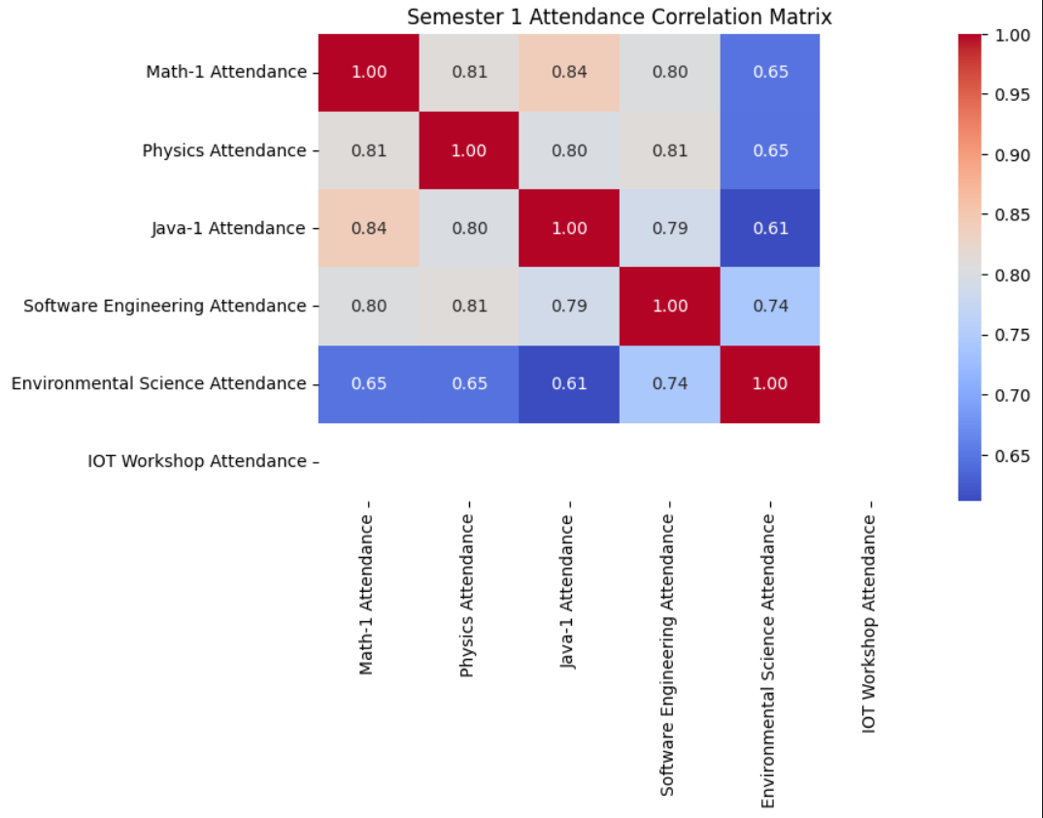

#### **4.1.2 Semester 2 Attendance Trends**

* Correlations weaken in Semester 2, suggesting independent attendance behaviors.
* **Mathematics-2 and Data Structures attendance (0.78)** show that students focusing on mathematics also prioritize programming subjects.
* **Physics and Electronics attendance (0.62)** highlight the conceptual continuity between these subjects.

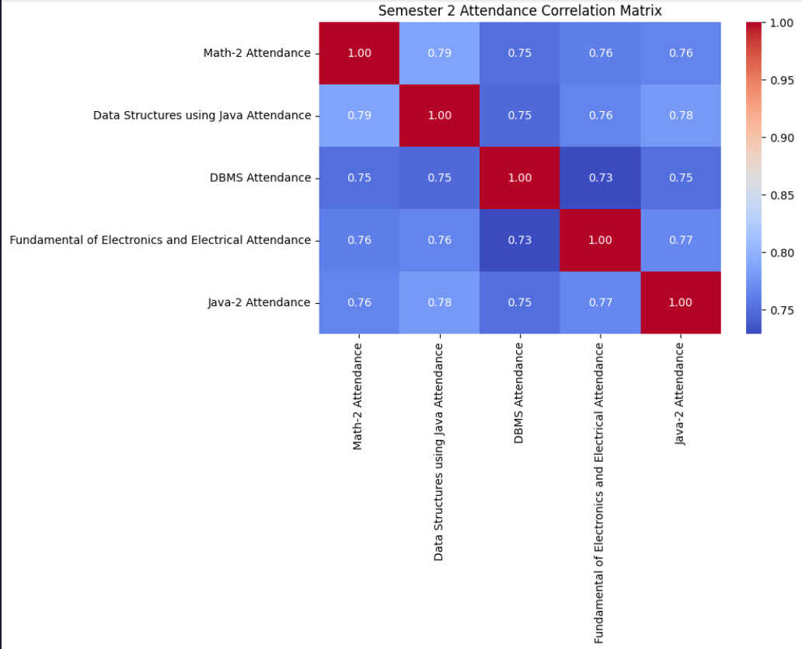

Predecessor-Successor Pair: Attendance

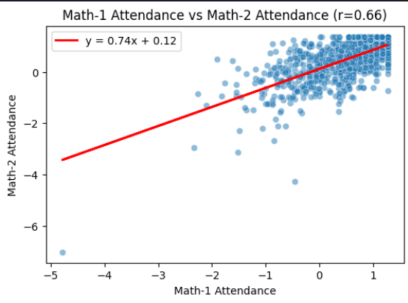

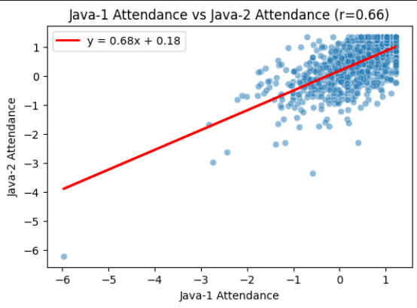

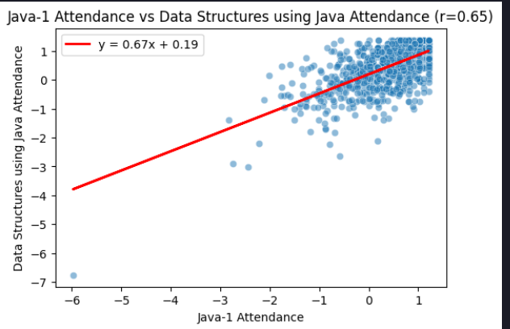

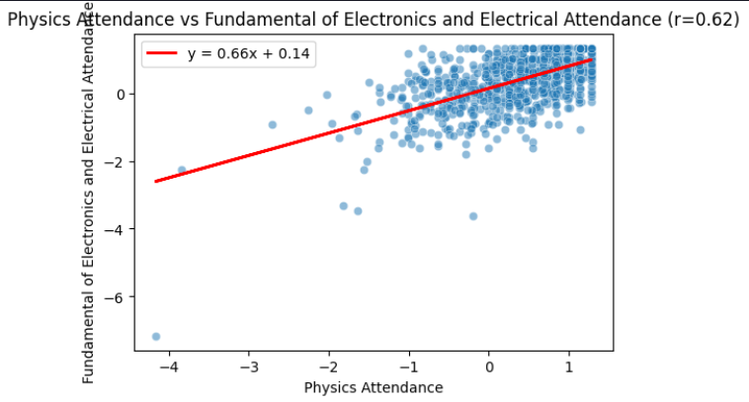

### **4.2 Theory Performance Analysis**

#### **4.2.1 Semester 1 Theory Trends**

* **Mathematics-1 and Physics Theory (0.73)** indicate strong interdependencies due to overlapping problem-solving skills.
* **Physics and Software Engineering Theory (0.78)** emphasize the importance of structured analytical thinking.
* Strong predecessor-successor correlations: **Mathematics-1 & Mathematics-2 (0.75)** and **Java-1 & Java-2 (0.81)** show foundational knowledge is key to success in subsequent courses.

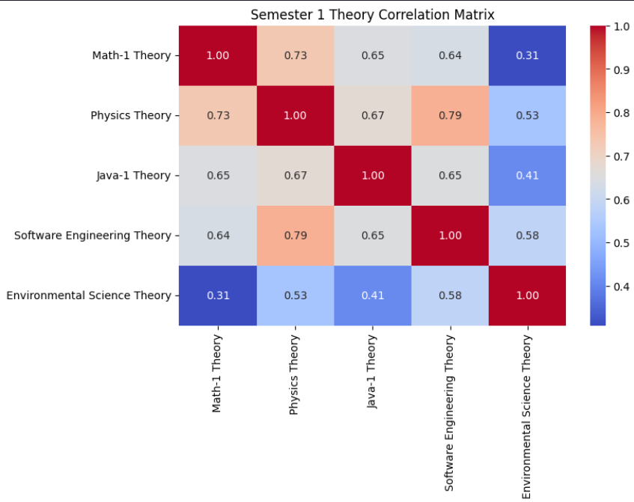

#### **4.2.2 Semester 2 Theory Trends**

* **DBMS and Data Structures Theory (0.78)** suggest computational subjects are interrelated.
* **Physics and Electronics Theory (0.79)** highlight scientific continuity.
* **Java-1 and Data Structures Theory (0.64)** indicate early programming concepts impact later performance.

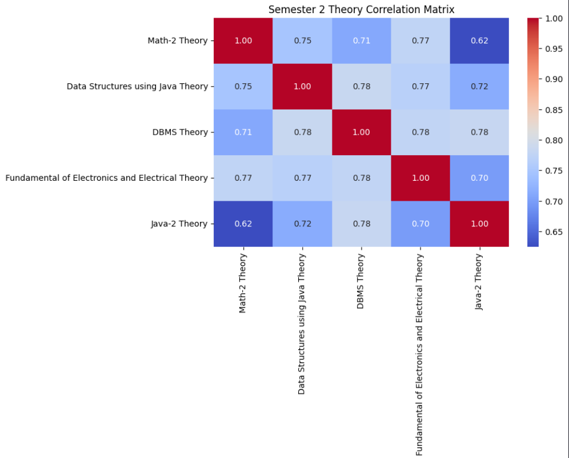

Predecessor-Successor Pair: Theory

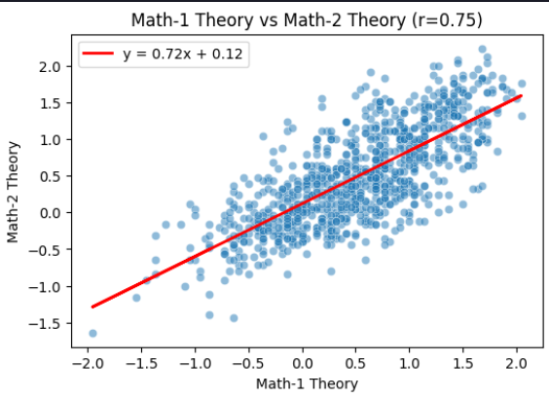

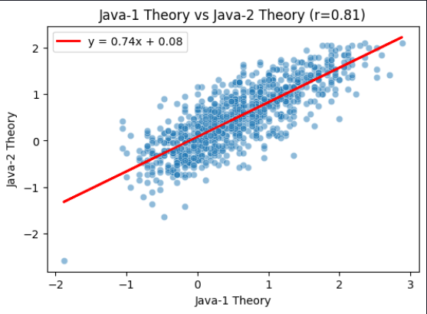

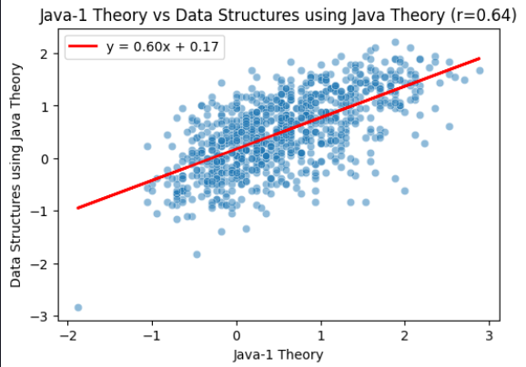

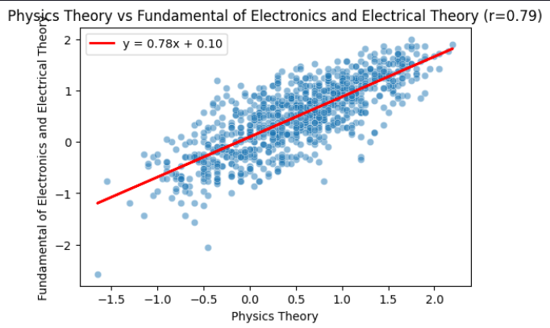

### **4.3 Practical Performance Analysis**

#### **4.3.1 Semester 1 Practical Trends**

* Practical correlations are weaker than theory and attendance trends.
* **Java-1 Practical and IoT Workshop Practical (0.39)** suggest a hands-on learning pattern.
* **Java-1 & Java-2 Practical (0.39)** and **Physics & Electronics Practical (0.36)** indicate inconsistent skill application.

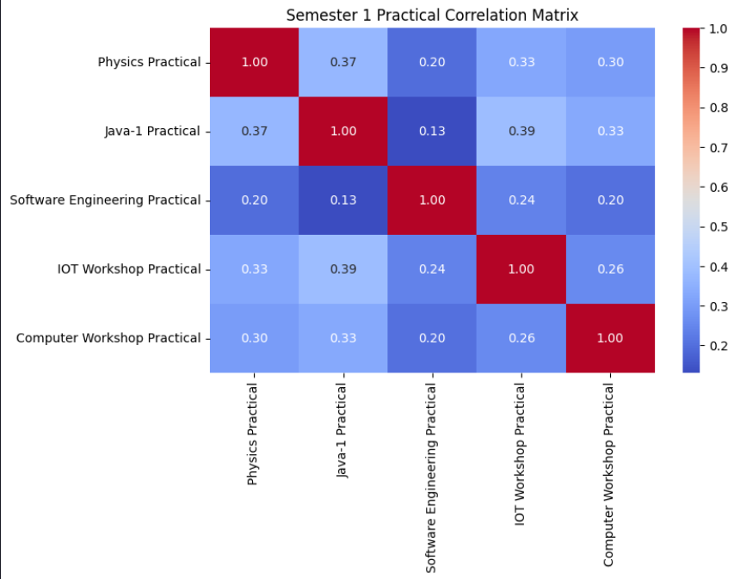

#### **4.3.2 Semester 2 Practical Trends**

* **Data Structures Practical and Java-2 Practical (0.94)** show highly transferable programming skills.
* **DBMS Practical and Java-2 Practical (0.89)** reinforce database management and programming overlap.
* **DBMS Practical and Data Structures Practical (0.90)** emphasize their complementary nature.

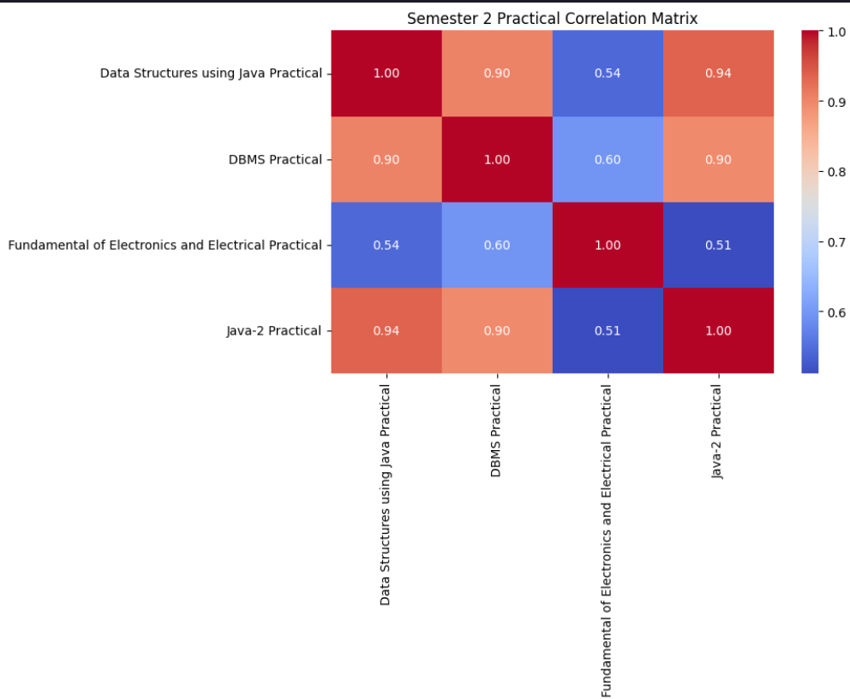

Predecessor-Successor Pair: Particular

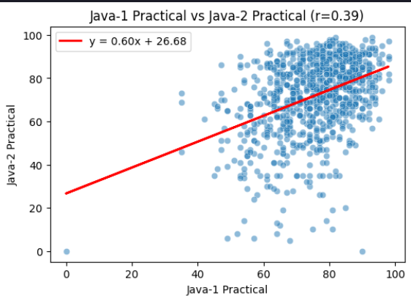

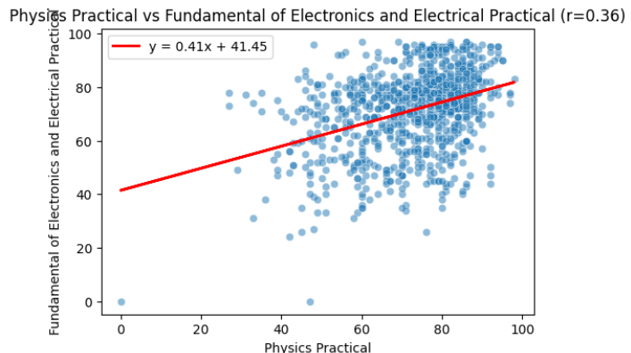

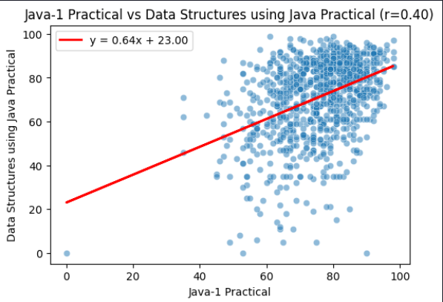

### **4.4 Conclusion**

* **Attendance and Performance Correlation:** Strong attendance in early semesters positively impacts academic performance. Mathematics and Java attendance correlations suggest that students disciplined in math also develop strong programming habits.
* **Subject Interconnections:**
  + **Mathematics and Physics:** A strong correlation between Mathematics-1 and Physics theory scores (0.73) suggests that students excelling in math are more likely to perform well in physics.
  + **Programming and Computational Subjects:** Java-1 and Data Structures theory scores (0.64) highlight the progressive learning nature of programming courses.
  + **Physics and Electronics:** High correlation (0.79) indicates that physics fundamentals are essential for success in electronics.
* **Practical Skill Retention:** Practical performance shows weaker correlations, suggesting that students struggle to consistently apply hands-on knowledge across semesters. Strengthening project-based learning could improve retention.

### **4.5 Key Educational Implications**

1. **Encouraging early attendance discipline** improves academic outcomes.
2. **Curriculum should reinforce conceptual continuity** (e.g., aligning physics and electronics courses more closely).
3. **Project-based learning strategies** should be implemented to enhance practical knowledge retention and application.